

* Maison Anna Clara

Maison Anna Clara

[www.piconvantkot.be/maisonannaclara](http://www.maisonannaclara.be)

1 My story 4

2 Maison Anna Clara 4

2.1 Features Maison Anna Clara 4

3 Accomodation Maison Anna Clara 4

3.1 Internet and tv 5

3.2 Board games 5

3.3 Washing machine and dryer 5

3.4 Toilet 5

3.5 Heater 5

3.6 Shower 6

3.7 Garbage bins 6

4 House regulations 7

4.1 General booking and rental conditions 7

4.1.1 Booking and payment 7

4.1.2 Cancellation 7

4.1.3 General 8

4.1.4 Safety 9

4.1.5 Respect and Privacy 10

5 Nieuwpoort 10

5.1 Sightseeing 10

5.1.1 Fishing port 10

5.1.2 Promenade 10

5.1.3 Yacht harbor 11

5.1.4 Natural reserve “De IJzermonding” 11

5.1.5 Jeanne Panne 11

5.1.6 King Albert I monument 11

5.1.7 De Ganzepoot 12

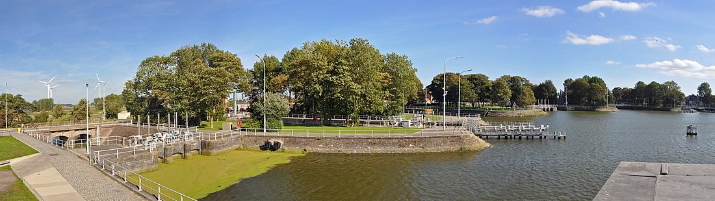 12

5.2 Parking in Nieuwpoort 13

6 Food & drinks 14

7 Local shops 16

8 Bank and ATM 16

9 Medical assistance 17

# My story

Hello! I'm Melissa Ceulemans. In June 2011 I bought this apartment and lived here for 8 years. I've made some great memories here... laughing, cursing, meeting, sharing, ... Today I'm opening my apartment for you, people from all over the world, to enjoy, to love, to share, to meet, to unite. My holiday apartment got the name of my dear grandmothers, Anna & Clara. The beautiful memories that I cherish of both are forever attached and immortalized in this apartment. They were both very warm people with a big heart. Everyone was always welcome at their home and enjoyed their unconditional hospitality. From this perspective and with the same clear message I wish you a warm welcome to Maison Anna Clara. I hope that you will feel at home here as well and can fully enjoy the peace and quiet and the beautiful Nieuwpoort. Have a nice holiday!

For questions and other matters I can always be reached at the number

+32(0)493 25 45 65. If possible, I will do my utmost to help you.

# Maison Anna Clara

In this collection you will find all kinds of information about Maison Anna Clara and Nieuwpoort. I have compiled as much information as possible to make your stay as pleasant and carefree as possible. If you have any questions, additions or a message that may be additional for other guests and their stay, please do not hesitate to mail it to info@maisonannaclara.be. This way I can offer a better service to other guests with your findings. Do not hesitate to leave a message in the guestbook or on the facebook page Maison Anna Clara. Thank you in advance!

## 2.1 Features Maison Anna Clara

Maison Anna Clara is centrally located, with a beautiful view of the Leopold II-park in Nieuwpoort. Here you can enjoy the sunshine or enjoy a delicious picnic. In Maison Anna Clara you will find a beautiful picnic basket and a matching blue blanket that you can use during your stay.

At the entrance of the Leopold II-park, side Stationlaan, you will find the swimming pool. The pool has a 25m pool and a children's pool with slide and fountain.

Maison Anna Clara is 280 m from the market square, 750 m from the promenade and the marina and 4.3 km from Nieuwpoort pool. Discover other towns and villages that are easy to reach by coastal tram or train. For the kids, Plopsaland De Panne is highly recommended. You can easily reach the amusement park with the coastal tram, stop Plopsaland.

# Accomodation Maison Anna Clara

Maison Anna Clara is a holiday apartment for 2 persons and one child up to 4 years old. There is one bedroom with box spring, provided with bed linen. There is also a travel cot with mattress and duvet. Please let us know in advance if your son or daughter is coming along. I make sure that the travel cot is already ready. There is also a kitchenette with living room, a bathroom with shower and sink and separate toilet. In the basement there is also a large storage room. The other facilities are described separately below.

## 3.1 Internet and tv

Free internet is provided. Below you will find the wifi codes.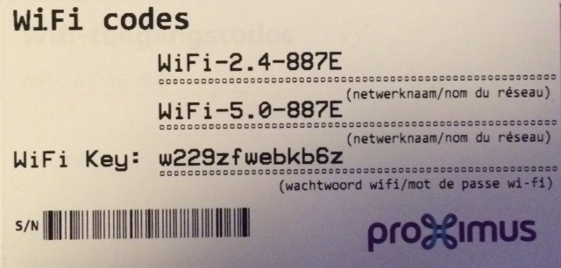

The use of the internet is your sole responsibility. Downloading illegal content is prohibited.

You can turn on the TV by pressing the top button on the right side of the TV. Then the TV will switch on, please be patient as this takes a few seconds. When the TV is switched on, you can continue using the Proximus remote control. In principle, you don't need the other Sony remote control.

## 3.2 Board games

To brave the colder days there are several board games available. You will find them in the wooden box.

## 3.3 Washing machine and dryer

There is also a washing machine and dryer. The washing machine is located in the holiday apartment, the dryer is located in the storage room in the basement. The key to the basement can be found in the key cabinet. Please always hang it back in the key cabinet.

## 3.4 Toilet

The toilet is located in the hallway. The key can also be found in the key cabinet, next to the tv, on the wall.

## 3.5 Heater

The heating works on electricity. You can easily operate it with the remote control. To turn on the heating, press the ON button and a green light will come on automatically. You can reach the desired temperature by pressing the buttons up or down.

However, please deal with the heating as a good housewife.

## 3.6 Shower

Please open the tilt window or turn on the fan with heat recovery when showering. The fan can be controlled with the remote control. You turn the device on with this button and then click on the + arrow a few times.

This way you limit the condensation in the apartment.

May I also ask you to put the remote control in the same place, please. (See photo)

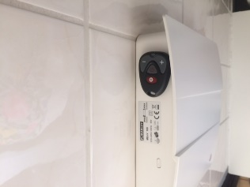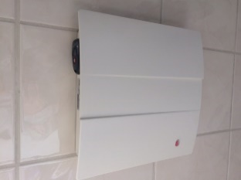

## 3.7 Garbage bins

There is a dustbin in the kitchen, in the bathroom and in the toilet. In the bin in the kitchen you have a bin for residual waste and for PMD. Please recycle carefully. Before you leave, may I kindly ask you to empty all the bins and put them in the correct bin in the storeroom.

In the hallway there is a red bin available to dispose of the glass and cardboard. On Friday morning the cleaning lady comes by to clean the stairs and the corridor. She also takes the glass and cardboard with her.

# House regulations

Below you will find the house rules. These house rules give you a clue how I prefer that you deal with the holiday apartment. I have formulated some rules and I hope you will agree with them. By respecting the rules, you help me to offer the best possible service to the other guests and to you. These house rules are intended to provide you with a pleasant, trouble-free and carefree stay. Please respect the house rules that I have carefully listed.

## General booking and rental conditions

The general reservation and rental conditions form part of the rental agreement between the tenant and the landlord. Booking the holiday apartment makes the precepts binding and implies that you agree with the predefined conditions.

### Booking and payment

This applies only to guests who have booked through the Maison Anna Clara website: [www.piconvantkot.be/maisonannaclara](http://www.maisonannaclara.be).

* You can book by email.
* The general reservation and rental conditions are part of the rental agreement between the tenant and the landlord.
* Booking the holiday apartment makes the precepts binding and implies that you agree with the predefined conditions.
* There are NO booking choices.
* Every question (by phone or e-mail) will be confirmed by the landlord by means of a booking confirmation by e-mail. The booking confirmation contains the total amount to be paid, i.e. the total rent + deposit of 150 euros. The payment must be deposited within 14 days after receipt of the booking confirmation to the account of the landlord listed in the booking confirmation.
* If the booking was made less than 14 days before the start date of the stay, then the full amount will be paid at the time of booking.
* In case of late payment, the lessor is entitled to cancel the booking.

### Cancellation

This applies only to guests who have booked through the Maison Anna Clara website: [www.piconvantkot.be/maisonannaclara](http://www.maisonannaclara.be).

Cancellation by the tenant:

* The tenant can cancel any booking without penalty up to 30 days before the arrival date.
* Cancellations must be made by e-mail: info@maisonannaclara.be. You will receive an email with the confirmation of receipt.
* In case of cancellation less than 1 month up to 10 days before your arrival date, the cancellation fee is 50% of the rent.
* If you cancel less than 10 days before the start of your stay, the cancellation costs are 100% of the rent.

Cancellation by the landlord:

* If force majeure or any other pressing reason obliges the landlord to cancel, this will be immediately notified to the tenant and, if possible, an alternative will be offered. If the tenant does not accept this alternative, or if the landlord is unable to offer an alternative, the rent already paid will be immediately refunded to your account. The tenant has no other right than to claim the rent due.

### General

* You may enter the holiday apartment from 4 p.m. onwards. Departure from the holiday apartment must take place on the last day of the rental period, at the latest at 11.00 in the morning. Receiving and returning the keys is agreed between tenant and landlord. The loss of a set of keys will be accompanied by a cost of 50 euros.
* A deposit of 150 euros will be charged. The deposit will be refunded to your account within 5 days after your departure, after deduction of any damage, breakage or loss.
* The tenant is liable for any loss and/or damage to the apartment and its furnishings, if this is the result of acts or omissions by yourself or third parties who are in the apartment with your permission. No one will intentionally damage anything in the apartment, yet it can happen to anyone that something breaks. I appreciate it if you report any damage to me quickly, so that I don't find out about it until after you leave. The house will be checked for defects and missing items before new guests arrive, so they can enjoy a comfortable holiday.
* There should never be more people in the apartment than those registered in the written confirmation of the booking. In case of infringement, access to the apartment may be denied.
* The owner is authorized to put an end to any stay if the guests are clearly intolerant or do not respect the rules of life and good neighbourliness, this without the refund of the rent paid.
* Animals are not allowed in the apartment.
* Please do not move the furniture. This may cause unnecessary damage and wear and tear to the furniture and walls.
* Please treat the apartment and its contents with care, so that the other guests can also enjoy a pleasant and carefree stay.
* The landlord is under no circumstances liable for:
* any disruption, alteration or prevention of the tenant's stay if this is the result of unforeseen and/or insurmountable events.
* inconveniences caused by the work of third parties such as municipal, provincial and government agencies. This also includes nuisance due to renovation works in the building, construction and/or rebuilding activities in the vicinity of the rented holiday apartment.
* Injury to the tenant as a result of staying in the rented holiday apartment.
* loss, theft and damage of/to personal property or vehicles belonging to the tenant.
* interruption of utilities, such as water, electricity, gas.
* The price includes:
* the use of the property for the reserved period.
* water, electricity and heating are included in the price.
* kitchen, bath and bed linen.
* final cleaning.
* Final cleaning is provided by the landlord. However, in spite of this cleaning, the tenant must make the following arrangements before departure:
* The holiday apartment is completely tidy, i.e. all household goods must be returned to their original state.
* The kitchen is left neat and tidy, the refrigerator and freezer are emptied and cleaned.
* All crockery, cutlery, etc. are washed and dried in their original place.
* The washing machine and dryer are left empty.
* The garbage cans in the kitchen, the toilet and the small trash can in the bathroom are emptied and disposed of in the corresponding trash can in the storage room.
* Glass and cardboard are deposited in the red bin in the hallway.
* sheets, kitchen towels and bath towels are disposed of in the black laundry basket.
* if not disposed of as required, the extra time will be charged at 25 euros per hour and will be deducted from the deposit.

### Safety

* The stairs, corridors and doors must be kept clear in order to allow quick and easy evacuation of the building.
* There are two smoke detectors in the apartment, one in the bedroom and one in the living space. Next there is a smoke detector outside at the entrance of the apartment, at the entrance of the storage room in the basement and in the storage room.
* There are two fire extinguishers, one foam extinguisher at the entrance of the holiday apartment and one powder extinguisher in the red cupboard in the bedroom (see label with fire extinguisher on the cupboard). If you can extinguish the fire yourself, this is allowed. Make that decision yourself and don't put yourself in danger!
* Instructions in case of fire:
* Stay calm
* Call the fire department: 112
* Provide the following details: name, address, reason for calling, location of fire, report that there are other people in the
* Show up
* Evacuate
* If possible, inform the other occupants of the fire (remember that your own safety is paramount!).
* It is strictly forbidden to smoke in the apartment.
* Your own electrical appliances must be technically in order and must not overload the electrical installation.
* There is no fixed telephone in the building. It is therefore advisable to have your own mobile phone. A list of useful telephone numbers can be found in the information leaflet on page 17-18.
* Keeping fireworks in the house and lighting fireworks around the house is strictly forbidden.

### Respect and Privacy

In the building are a total of 7 apartments. There are 8 other people living in the building. Please also respect the peace and privacy of the fellow residents. From 22.00h there should be no more noise nuisance.

# Nieuwpoort

Nieuwpoort is without a doubt one of the pearls of the Belgian coast. Nieuwpoort consists of two parts, Nieuwpoort-stad and Nieuwpoort-bad. Maison Anna Clara is located in Nieuwpoort-city with a view on the beautiful city park.

Nieuwpoort-bad has a traffic-free seawall and a beautiful sandy beach. You can easily and carefree travel by coastal tram to Nieuwpoort-bad and enjoy the sea and our beautiful sandy beach. It is best to get off at the stop Nieuwpoort-bad.

## 5.1 Sightseeing

### 5.1.1 Fishing port

In the morning there is always a lot of activity in the urban fish market. Several times a week there is a supply of fresh fish that is auctioned on the spot. The fish that is traded can be bought directly in the fish shops on the quay or tasted in one of the local fish restaurants. Promovis vzw supports the Nieuwpoort fishery.

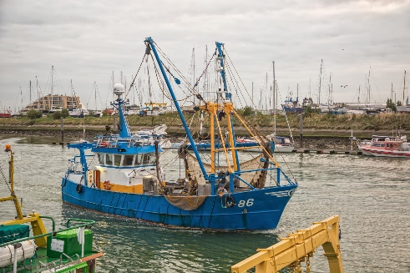

**Fishing boat Surcouf**

Walk along the quay and discover the Surcouf, an authentic and restored fishing vessel, which is shown on land. Surcouf fished for sole, plaice, cod, turbot, brill, dab, bone, whiting and shrimp.

### 5.1.2 Promenade

Between the marina and the North Sea is a distance of about 2 km, the harbor channel. Along the Havengeul a completely new cycling and walking promenade has been constructed, which forms a perfect connection between the historic centre and the quay on the one hand, and the seaside resort on the other hand. Approximately halfway along this route, a watchtower has been built above the water, offering magnificent views over the marina, the mouth of the river IJzer and the nature reserve. You can also walk along the pleasant dike with a view of the beach and the sea.

### 5.1.3 Yacht harbor

Nieuwpoort has the largest marina in Northern Europe with about 2000 berths. Along the quay which is about 1 km along, lie the colorful fishing boats. This concerns both shrimp ships and small and large trawlers.

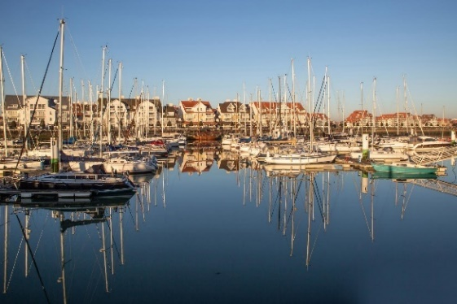

### 5.1.4 Natural reserve “De IJzermonding”

At Nieuwpoort, the river IJzer flows directly into the sea. Where salt and fresh water meet, a special biotope with mud flats, salt marshes, dunes, beaches and polders has developed. Thanks to an extensive network of cycling and walking paths, you can enjoy the natural beauty of the IJzer estuary. Useful information panels will tell you everything about this wonderful nature reserve along the way. You can use the ferry for this purpose.

### 5.1.5 Jeanne Panne

Newport is a city of witches, that much is clear. In the first half of the 17th century, more specifically between 1602 and 1652, no less than 17 witches, men and women, were burned at the stake in Nieuwpoort.

Nieuwpoort commemorates Jeanne Panne every three years by means of a historical evocation. The city is flashed back to the 17th century. On several locations scenes from the life of Jeanne Panne are evoked. In addition to the great evocation, other events about Jeanne Panne are also planned.

### 5.1.6 King Albert I monument

This monument was erected as a lasting tribute to all Belgian front soldiers and their captain, the "Knight-King" Albert I. The place symbolises the important role played by the "Goosefoot" lock complex during the First World War. From here, the underwatering of the IJzervlakte was achieved.

### 5.1.7 De Ganzepoot

From the long bridge on the west side of the complex, in a semi-circular form (hence the name "Ganzepoot"), there are six hydraulic engineering works. These provide alternately for the drainage of part of the Polders and for the shipping connections. Drainage takes place via a spillway, the barges pass a lock.

The original works of art, dating from the second half of the nineteenth century, were completely destroyed during the First World War. From here, at the Battle of the Yser, the IJzervlakte was flooded in order to stop the advancing Germans. The infrastructure was rebuilt immediately after the end of the hostilities in a slightly modified form.

### 

In short, in Nieuwpoort there are several places of interest and possibilities for a pleasant stay. There are several cycling and walking routes and several beautiful parks for a nice picnic. Nieuwpoort is also popular because of its war tourism with famous monuments. Underneath the impressive King Albert I monument in honour of the victims of WWI, lies the Westfront. This is the place where the course of the German invasion of Belgium in 1914 is marked. There is also a visitor's centre where you can immerse yourself in the history of the war.

Nieuwpoort has also been crowned a nice shopping city. In the shopping street of Nieuwpoort-bad you will find several nice and trendy shops.

For more information about Nieuwpoort, I refer you to the site of Nieuwpoort: [www.nieuwpoort.be](http://www.nieuwpoort.be)

## 5.2 Parking in Nieuwpoort

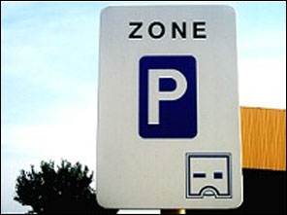In Nieuwpoort City you can park your car for free, except on the Kaai. There you have to pay to park your car. In the city centre you can park your car for free. In some streets it is mandatory to put a parking disc for max. 2 hours. This is indicated by this sign:

**In Nieuwpoort-bad you have to pay for parking.** Below you can read about when this applies. There are also underground parking spaces.

Paying parking in Nieuwpoort

- 1 April to 30 September. You have to pay for parking every day between 10:00 and 19:00.

- 1 October to 31 March. You only have to pay for parking on Saturdays, Sundays, legal holidays and during school holidays between 10:00 and 19:00.

A good and solid alternative is to leave your car in Nieuwpoort-city and take the bus or coastal tram to Nieuwpoort-bad or another coastal town. You can buy a ticket via the app of De Lijn or via the number 4884 with the message DL. During the summer months the counter of De Lijn is open. You can also buy a line ticket there. Another possibility is to buy a line ticket at the local newspaper shop.

The nearest bus stop is at the park. If you look out of the kitchen window, you will see the bus stop across the street. On this side of the street, the bus goes to Nieuwpoort quay, Lombardsijde, Westende, Middelkerke and Ostend (bus 68 or 69).

On the other side (with your back to Maison Anna Clara), there are buses to Nieuwpoort, Oostduinkerke, Koksijde, Veurne (bus 68 or 69).

More information about the bus can be found at www.delijn.be.

If you want to go to the beach of Nieuwpoort or another coastal town, you should take the coastal tram. The stop Nieuwpoort-stad is located on the quay, at 800 m from Maison Anna Clara. More info can be found at www.dekusttram.be.

# Food & drinks

**BRASSERIE AND RESTAURANT**

**Brasserie In de Luwte**

One of my favourites. A cosy brasserie with an honest and tasty cuisine. From a tasty sandwich and delicious pasta to a nice tender piece of meat. A varied menu. Be sure to check out the suggestions. The sangria or our Picon van 't Kot is highly recommended.

Address : marktplein 18, 8620 Nieuwpoort

Closing day : monday and tuesday

**Restaurant 'De Roos**

Restaurant De Roos is known for its delicious fish dishes. Steve d'Hoedt is the chef at 'De Roos' and loves to spoil his customers. He also tries to sell lesser-known fish dishes such as red gurnard, pretty girl, halibut, etc., and in this way to trigger the taste buds of his customers. Freshness is of the utmost importance to Steve, which is why the fish is auctioned fresh and delivered to the restaurant the same day.

Address : Kaai 14, 8620 Nieuwpoort

Closing day : tuesday and wednesday

**Restaurant De Vuurtoren**

De Vuurtoren is a brasserie-restaurant with an extensive menu.

Address: : Kaai 38, 8620 Nieuwpoort

Closing day : monday

**Restaurant Barbouni**

Restaurant Barbouni is a mediterranean restaurant, with greek dishes as main character.

Address : Kaai 14, 8620 Nieuwpoort

Closing day : tuesday

**Restaurant Julien**

A refined French cuisine in an original setting complemented by surprise menus.

Address : Marktplein 1, 8620 Nieuwpoort

Closing day : Monday and Sunday

**BREAKFAST**

**Bar Juliette (take away & delivery)**

Take away and delivery of breakfast and brunch baskets where quality, fresh and local are priority. There is an extensive range of well-stocked, diverse wraps, healthy fresh salads, original and very fresh sandwiches and delicious daily specials.

Address : Albert I-laan 78B, 8620 Nieuwpoort

Closing day : Wednesday

Fredt

Feel like having a delicious breakfast at a democratic price? Then be sure to stop by at Fredt. At lunchtime you can also enjoy a delicious sandwich, pasta or salad in a cosy interior. If you prefer to take your meal home, this is also possible here.

Address : Langestraat 49, 8620 Nieuwpoort

Closing day : Sunday

**CREAMERY**

**Oma’s ijs**

Grandma's ice cream is the place to be for delicious artisanal ice cream, as well as custom-made cakes. From cupcakes to theme cakes.

Address : Pieter Deswartelaan 17, 8620 Nieuwpoort

Closing day : -

**St.-Catherine**

The best creamery of Nieuwpoort is St-Catherine, with its artisanal ice cream and fresh sorbets. Since 1985 it has been a specialised ice cream parlour which has delighted many people.

Address : Albert I laan 185, 8620 Nieuwpoort

Closing day : -

**BAR, SUMMER BAR, BEACH BAR**

**Café 5 voor Twaalf**

Cosy bar with a terrace in the centre of Nieuwpoort, near the church.

Address : Onze Lieve Vrouwstraat 1, 8620 Nieuwpoort

Closing day : -

**Barcour**

Without doubt the most cosy summer bar in Nieuwpoort!

Address : Albert I-laan 126, 8620 Nieuwpoort

Closing day : monday and tuesday in june

**Bar Sjansaar**

Cosy bar on the border of Nieuwpoort-bad and Oostduinkerke.

Address: : Kinderlaan 5, 8670 Koksijde

Closing day : -

# Local shops

Below you will find addresses of various local shops. In Maison Anna Clara there are 2 large shopping bags in the white cupboards. You don't have to spend money on plastic bags and we also contribute to the environment.

Supermarket Delhaize 550 m from Maison Anna Clara

Kaai 47

8620 Nieuwpoort

Supermarket Colruyt 1,4 km from Maison Anna Clara

Jozef Cardijnlaan 33a

8620 Nieuwpoort

Supermarket Aldi 1,3 km from Maison Anna Clara

Albert I-laan 13

8620 Nieuwpoort

Newspaper Trade Andy 650 m van from Anna Clara

Oostendestraat 6

8620 Nieuwpoort

# Bank and ATM

Belfius 49 m van Maison Anna Clara

Astridlaan 60

8620 Nieuwpoort

BNP Paribas Fortis 600 m van Maison Anna Clara

Langestraat 56

8620 Nieuwpoort

# Medical assistance

**Ambulance : 112**

**Fire brigade : 112**

**Police : 101**

**Anti-poison centre : 070 245 245**

**Pharmacists on call Tel. 0903 922 48 -**[**www.apotheek.be**](http://www.aptheek.be/)

Amery, Kerkstraat 5, Nieuwpoort - Tel. 058 23 31 92

K. Matthijs, Albert I-laan 135, Nieuwpoort - Tel. 058 23 82 32

Sodiap - Lenaerts, Albert I-laan 255, Nieuwpoort - Tel. 058 23 41 22

Van Besien, Marktplein 12, Nieuwpoort - Tel. 058 23 35 35

**Hearing centre**

Veranneman, Franslaan 15, Nieuwpoort - T 058 31 25 66

**Doctors – watch post, Ieperse Steenweg 99, Veurne - Tel. 1733 -**[**www.hijw.be**](http://www.hijw.be/)

J. Debaecke - S. Kerkaert - G. Roobaert

Arsenaalstraat 32, Nieuwpoort – Tel. 058 23 31 74

F. Dewulf - T. Desmet, H. Declerck, A. Maes

Oostendestraat 5, Nieuwpoort - T 058 24 24 24 -[www.medihaven.be](http://www.medihaven.be)

L. Platteau, St. Bernardusplein 10, Nieuwpoort – Tel. 058 23 82 50

**Physical therapy**

H. Deblauwe, Franslaan 42, Nieuwpoort – Tel. 058 24 07 24

Kinepraktijk 'De Waterkant', P. Deswartelaan, Nieuwpoort – Tel. 058 23 42 16

Kinepraktijk ‘Westenwind’, Canadalaan 35 – Tel. 0498 62 92 09

**Dentist – watch post, Tel. 0903 39969 -** [**www.tandarts.be**](http://www.tandarts.be)

Coemelck D, Franslaan 35a, 8620 Nieuwpoort – Tel. 058 23 80 17

Maeyaert S, IJzerstraat 11, 8620 Nieuwpoort – Tel. 058 24 07 00